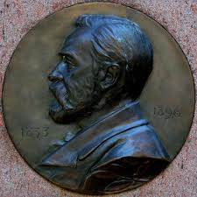 Dynamite

Match the picture and invention with the right name

1. Johan Petter Johansson
2. Alfred Nobel
3. Jan Jönsson
4. Gustaf de Laval

The correct alternative is: b.

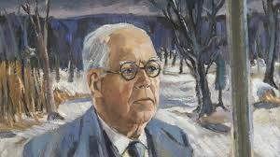 The wrench

Match the picture and invention with the right name

1. Johan Petter Johansson
2. Jan Johansson
3. Anders Celcius
4. Alfred Nobel

The correct alternative is: a.

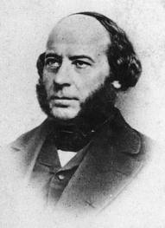 Propeller

Match the picture and invention with the right name

1. Ruben Rausing
2. John Ericsson
3. Olof Palme
4. Alfred Nobel

The correct alternative is: b.

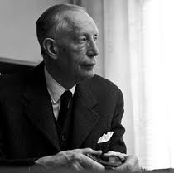 Tetra Pak

Match the picture and invention with the right name

1. Ruben Rausing
2. Björn Ulveus
3. Lars Svensson
4. Björn Borg

The correct answer is: a.

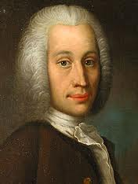 A scale for thermometers

Match the picture and invention with the right name

1. Ruben Rausing
2. John Ericsson
3. Anders Celcius
4. Gustaf Dahlén

The correct alternative is: c.